IT24101688
Nandasena O.V.T.H.N
Lab 05
EXERCISE

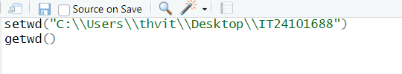

1.
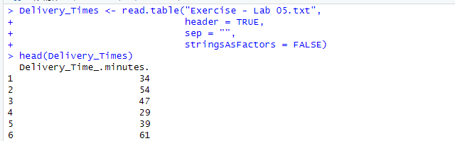

2.
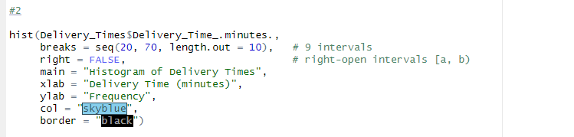
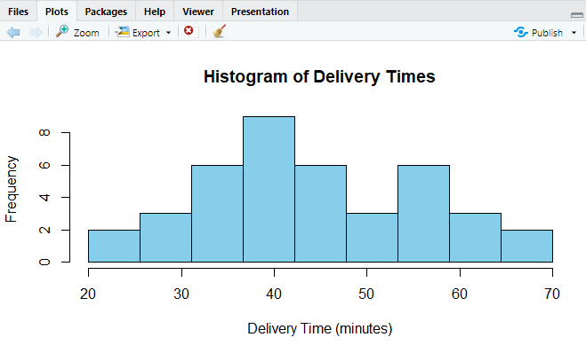
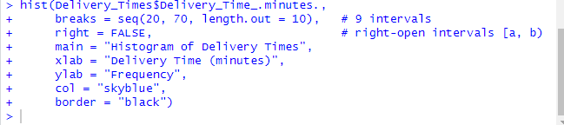

3.
The distribution of delivery times is roughly symmetric, centered around 40 minutes. Frequencies rise towards the middle (30–45 minutes), then fall off towards the ends (20–25 minutes and 65–70 minutes). There is no extreme skewness and the highest frequency (the “peak”) is around the 35–45 minute interval.
4.
